Task 4

1. Introduction
This report outlines the design, implementation, and analysis of a program designed to detect deadlocks across multiple system configurations. The program evaluates process allocations and outstanding resource requests to identify permanently blocked states.

2. Component Analysis
- Existence Vector (E): A 1D vector representing the total absolute instances of each resource type present in the system.
- Allocation Matrix (C): A 2D matrix tracking the quantity of each resource currently held by each process.
- Request Matrix (R): A 2D matrix tracking the outstanding, unfulfilled resource requests needed by each process to complete execution.
- Available Vector (A): A dynamically calculated 1D vector representing resources that are currently unallocated and free for use.
- Finish Vector (Finish): A boolean vector indicating whether a process can run to completion, initialized to true for processes holding zero resources.

3. Execution Flow
- Initialization & File I/O: The program expects the input file path as a command-line argument. It validates the argument count and opens the specified file, first reading the total number of test cases to execute.
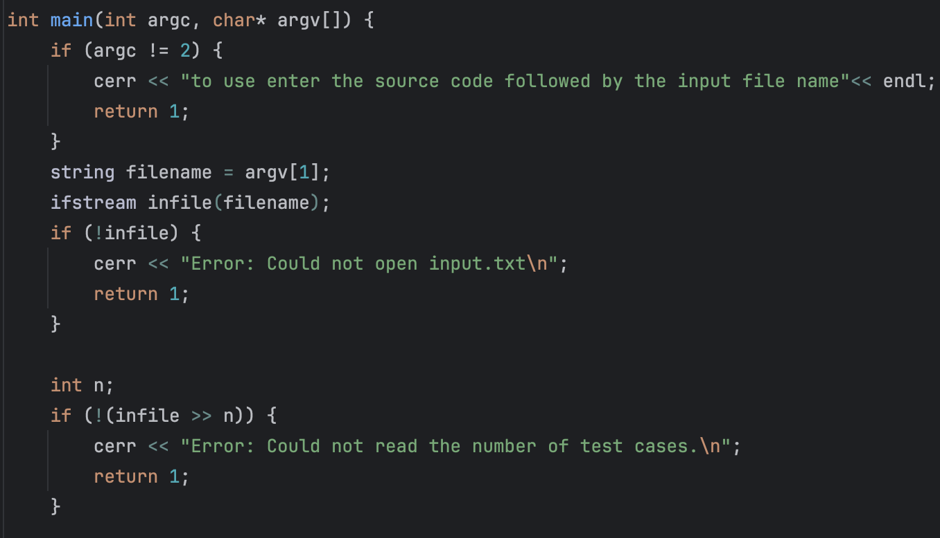
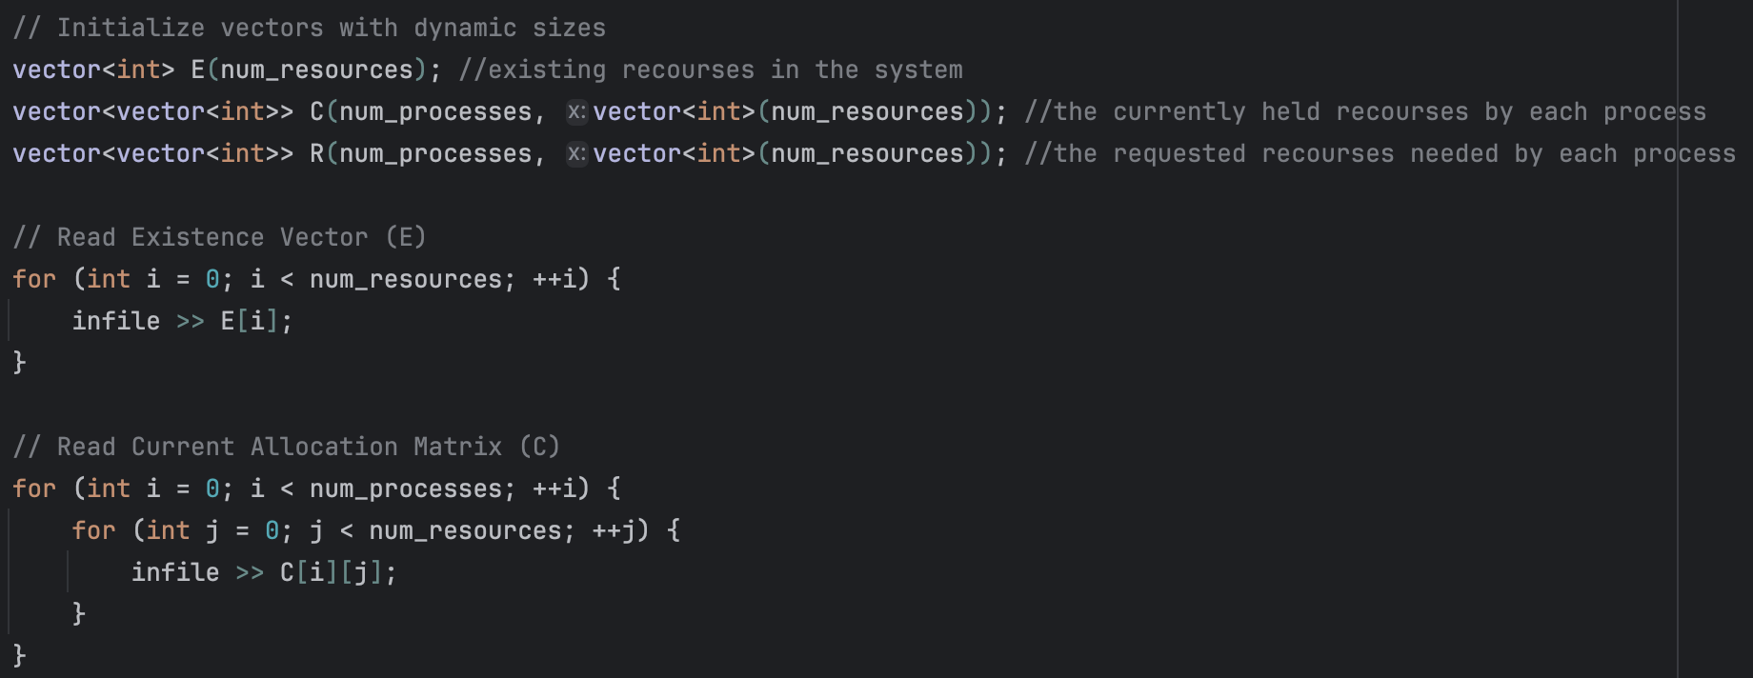
- Test Case Iteration: An outer loop processes each system scenario sequentially, re-initializing the E, C, R, and Astructures for every individual test case.
- Availability Calculation: For each scenario, the program computes the initial Available vector (A) by iterating through the Allocation Matrix (C) and subtracting all currently allocated resources from the Existence Vector (E).
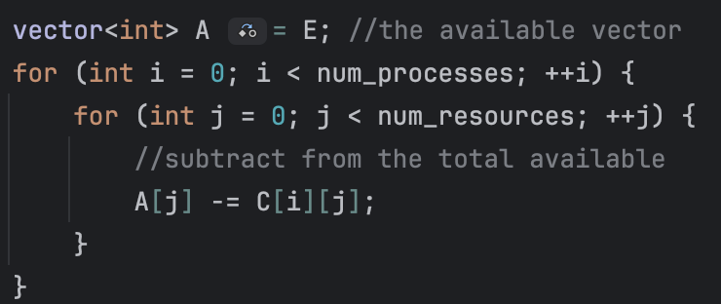
- Deadlock Detection Loop: A do-while loop continuously scans for unfinished processes.
  - State Logging: The system outputs trace messages (e.g., "Attempting to allocate for process: X") to provide real-time visibility into the algorithm's decision-making.
  - Failure Logging: If a process's pending requests (R) exceed available resources (A), the program logs the specific resource index that caused the failure, displaying the required versus available amounts.
  - Success Logging & Release: If requests are satisfied, the program simulates process completion. It logs the successful allocation, adds the currently held resources (C) back to the Available vector (A), prints the updated available resource counts, and marks the process as finished.
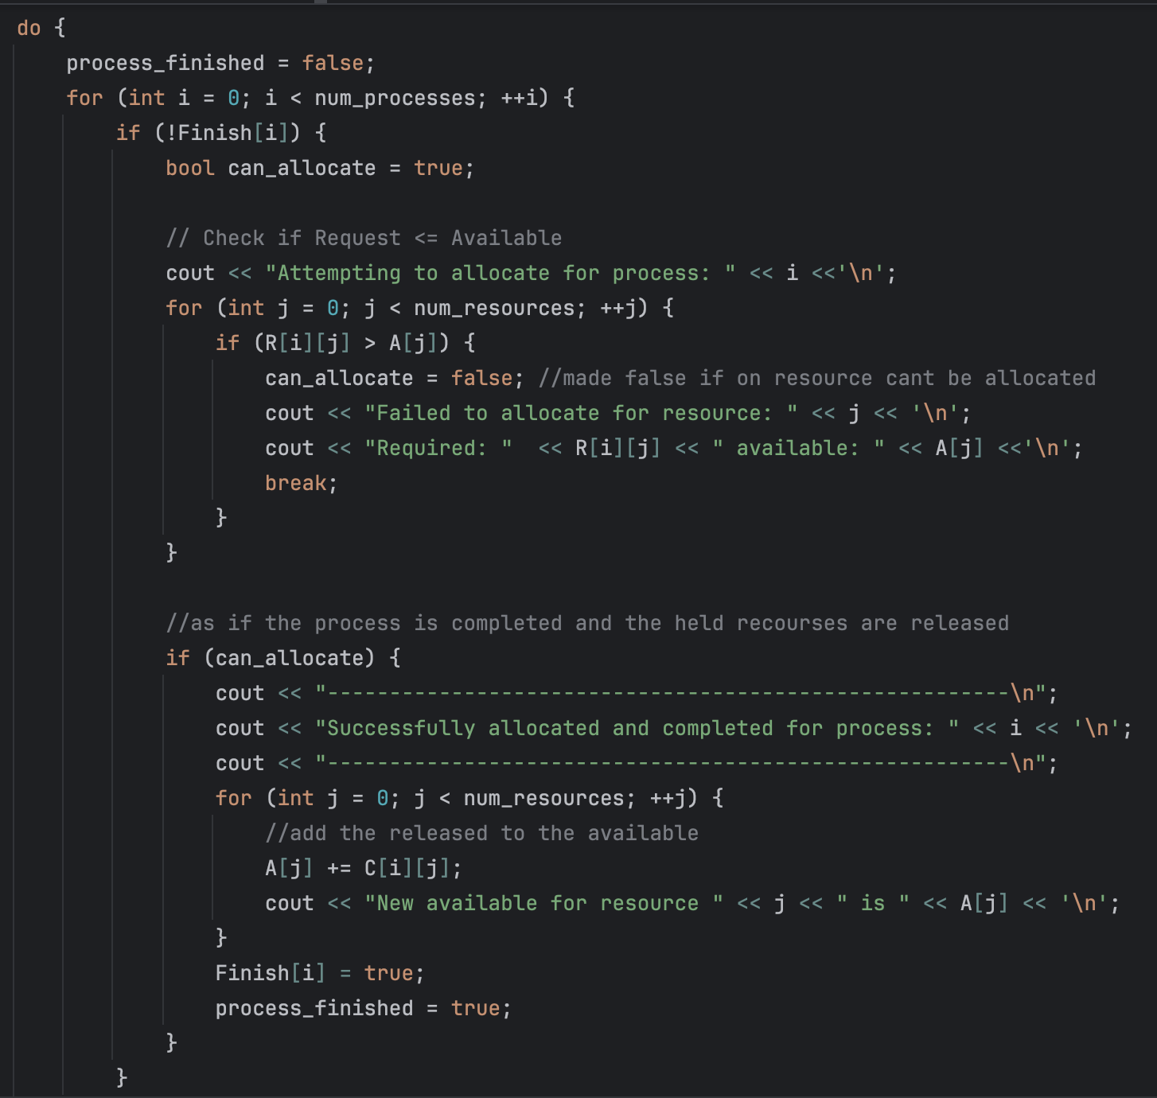

- Output Evaluation: The loop terminates when a full pass yields no new process completions. The system then evaluates the Finish vector, outputting the specific IDs of any deadlocked processes or confirming a deadlock-free state for that test case.
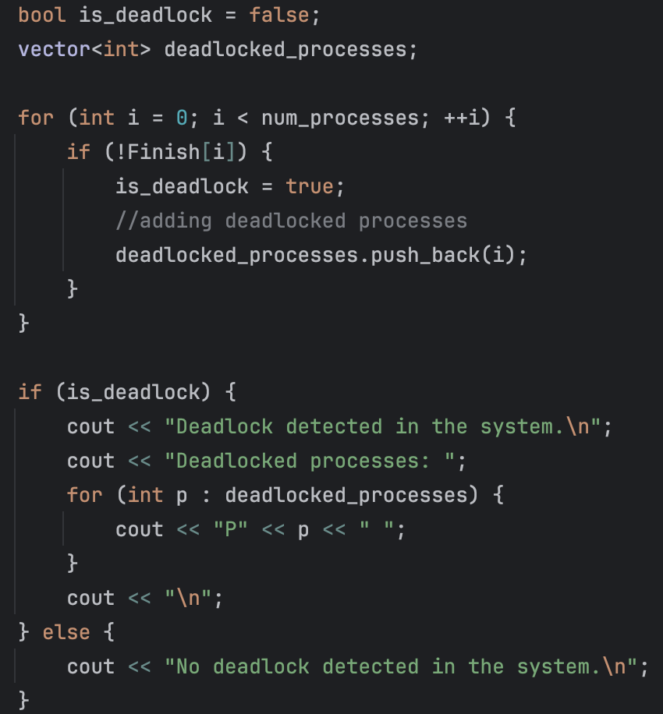

4. Conclusion
The code provides a robust and highly observable simulation of a multi-instance deadlock detection algorithm. By introducing test-case iteration and detailed console logging, it offers clear insights into the resource allocation lifecycle, allowing for precise tracking of how and why system deadlocks occur or are avoided across varying scenarios.

5. GitHub: repo
commit sha: 621074752b4778ca677da9ac93a131009ccb55cc

